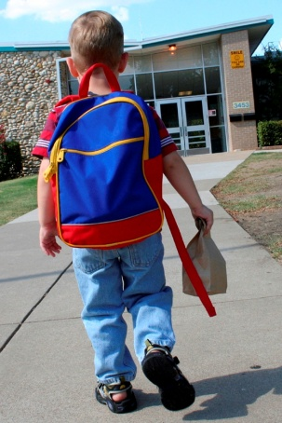

**St Lawrence’s Children’s Centre**

**Wednesday 12:45 to 14:45**

**27 Sep to 6 Dec 2017**

These courses are perfect for parents, carers or people wanting to work in schools. They are a great first step back into learning for those without GCSE A-C or 4+ in English and/or maths.

*Free courses with free childcare. Eligibility rules apply.

Come to a series of fun, free* and informal workshops

* Think about activities which develop your child’s communication skills
* Learn ways to support your child’s first stages at school
* Talk about children’s behaviour and internet safety
* Share ideas with other parents and carers
* Gain confidence in your own skills
* Ask questions to find out what ***you*** need to know!

**Do you have a pre-school or early years child?**

**Get Ready for School**

**What Do I Need to Know?**