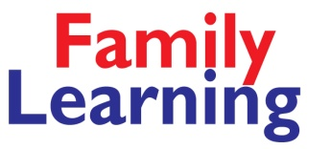

**Keep up with the Children in Maths**

**Fishergate Primary School**

**Tuesdays, 27 Sep 2016 – 4 July 2017**

**(term time only)**

**9.15 am to 11.15 am.**

**Our courses are taught in small, friendly groups in a relaxed and fun way. You will gain a qualification to widen job opportunities, improve your confidence AND be able to help your children with homework.**

To find out more about this course, contact Sally

🕾 07785 546366

[**sally.waudby@york.gov.uk**](mailto:sally.waudby@york.gov.uk)

**Would you like to improve your maths for FREE?\***

For more info phone **01904 554277**or email **york.learning@york.gov.uk**

**Family Learning, York**

**This course is free if you don’t have GCSE A-C maths**

**\*eligibility rules apply**